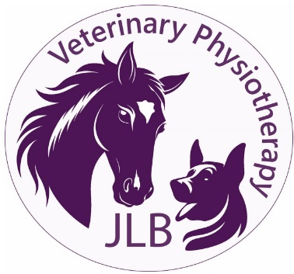 |  |  | JLB Veterinary Physiotherapy  Jade Bramley  (MSc) Veterinary Physiotherapy  Tel: 07941 884204  Email: jade@jlbvetphysio.co.uk
Veterinary Consent/Referral Form
Owner Details
Name |  |  | Address
Tel
Email |  |  | Postcode
Animal Details
Name |  |  | Sex
Breed |  |  | DOB
Insurance
Is the animal insured? YES/NO
Insurance company:
Veterinary information
This section MUST be completed and signed by the referring vet
Veterinary Practice
Vet Surgeons Name
Practice Address: |  |  | Tel
 |  |  | Email
Patient Summary
Summary of patient injury/condition, current medication dosage, with any areas of caution and relevant medical history:

Investigations (X-ray, MRI, ROM etc.) and their findings:

Medication:

Authorisation
I give my consent for the above-named animal to receive veterinary physiotherapy treatment from JLB Veterinary Physiotherapy.
Vet Signature: |  |  | Date:
I declare that I am the legal owner of the animal named above and all the information provided on this form is correct.
Owner Signature: |  |  | Date:
Please complete and sign the above. Email to jade@jlbvetphysio.co.uk

